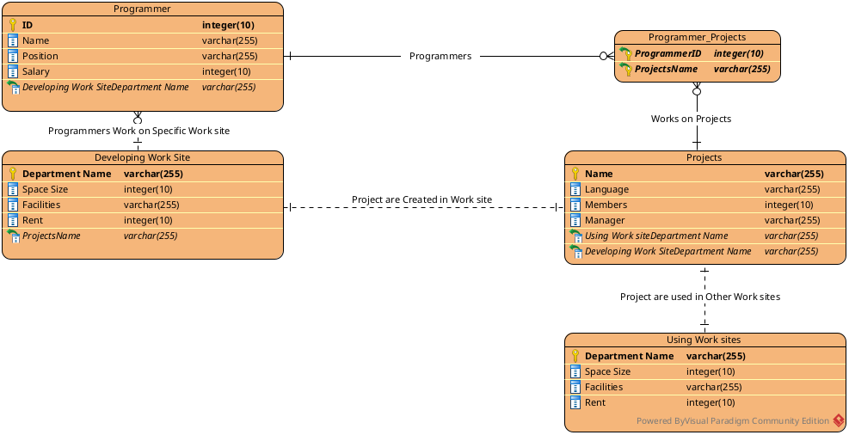

#Doc

We created a Programmer entity having (ID, Name, Position, Salary) as attributes.

Entity named Projects is created having (Name, Language, Members, Manager) as attributes.

Entity named Developing Work site is created having (Department Name, Space Size, Facilities, Rent) as attributes.

Entity named Using Work site is created having (Department Name, Space Size, Facilities, Rent) as attributes.

Now For the Relation .

programmer entity is at many to many relation with Projects as many programmer can work on single project whereas one programmer can work on many project as well. Then again Programmer entity have many to one relationship with Developing Work Site as many programmer can work in single developing site but cannot work at many developing site at same moment.

Project Entity also have the relationship with Using work site as explained in the question one project is developed at a single Working site but a program can be used at many working site , so project and Using work site have many to many relationship.

